Question 1: Personal Profile Web Page

Part 1: Create a Personal Profile Web Page using HTML only. (Marks 3)

- Add a proper page title.
- Add your name as the main heading.
- Add an About Me section using paragraphs.
- Add a Skills section using a list.
- Add a Contact section using email/contact link.
- Attach screenshots of your HTML code and browser output
HTML Code:
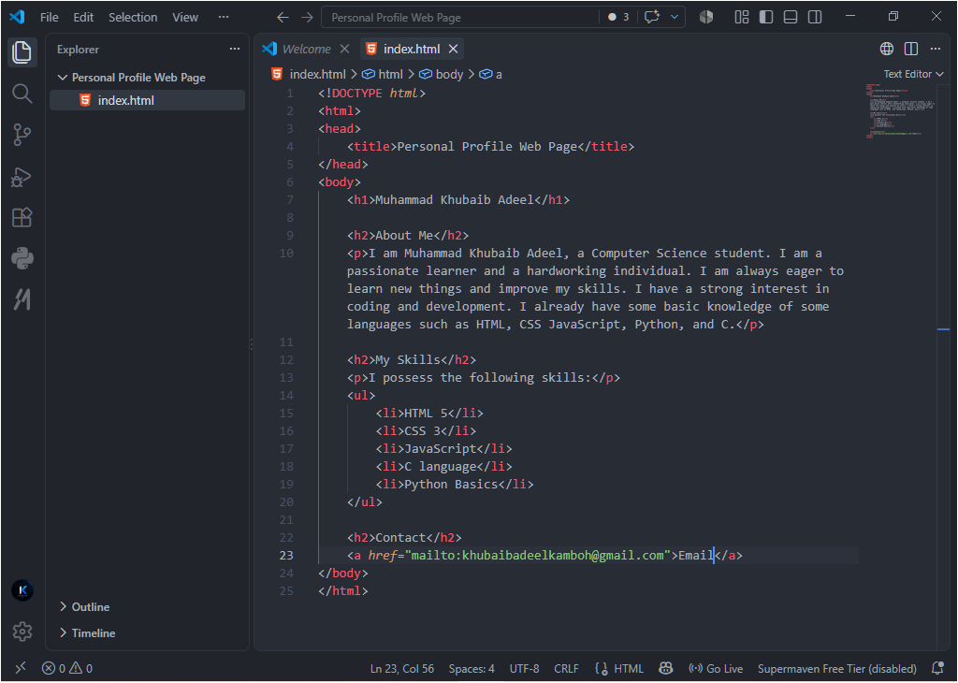
Browser Output:
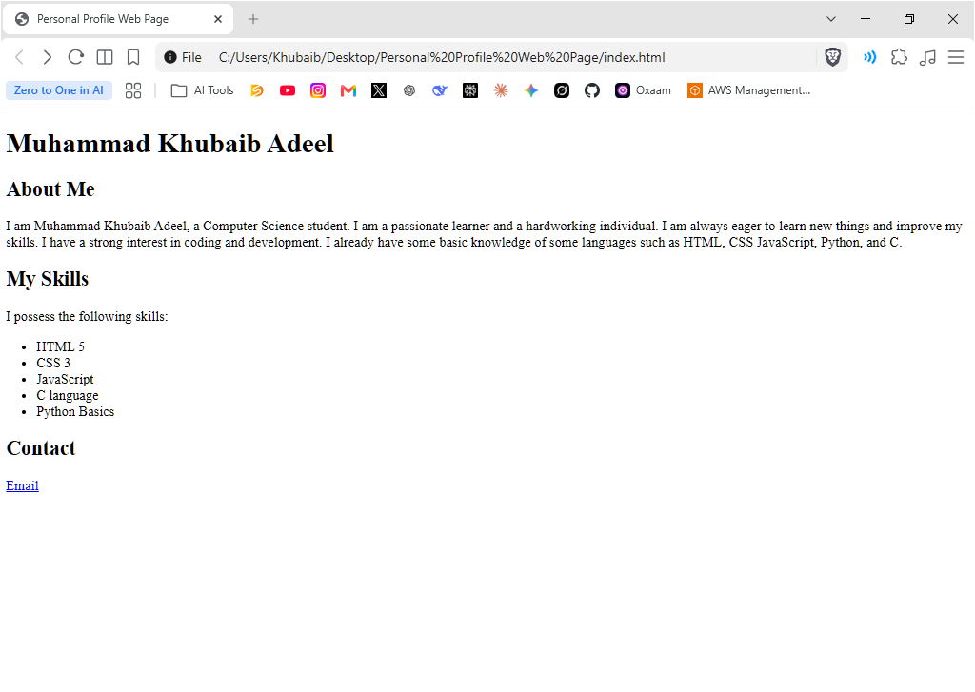
Part 2: Apply CSS or Tailwind CSS on the same Personal Profile Web Page. (Marks 2)
- Apply colors, spacing, borders, and font styling.
- Create a clean card/container layout for the profile page.
- Make the page responsive for different screen sizes.
- Attach screenshots of your CSS/Tailwind CSS code and final styled browser output.
HTML Code: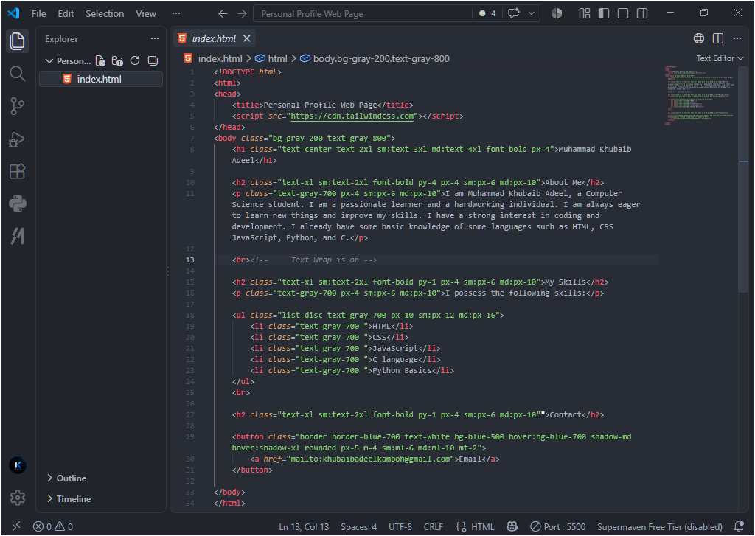Browser Output: 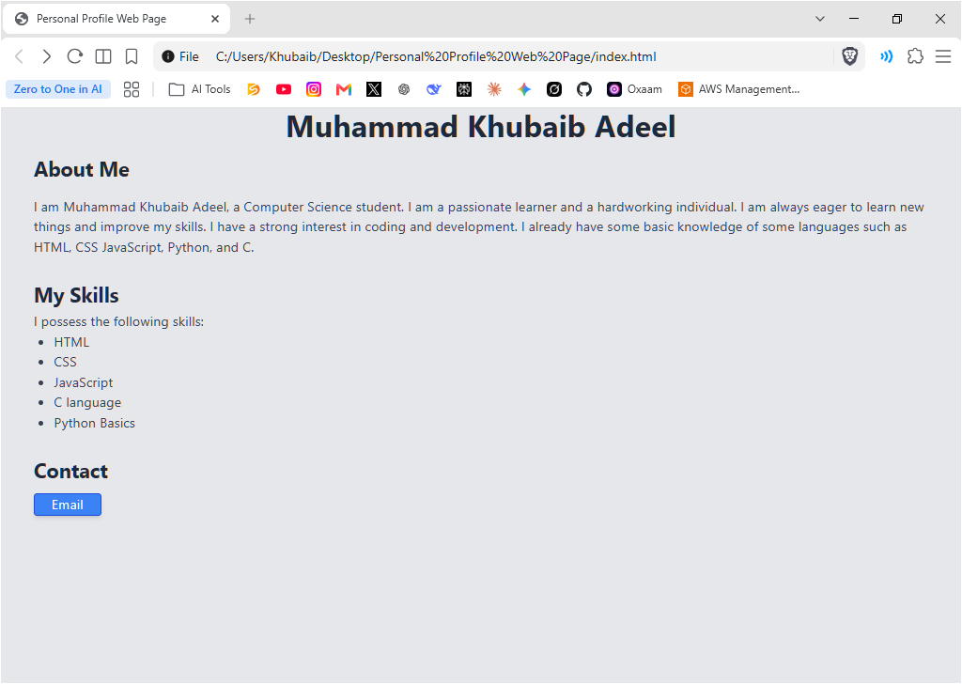
Question 2: Git Repository and Upload

Part 1: Build and initialize a Git repository for your Personal Profile Web Page. (Marks 2)
- Create a project folder for the Personal Profile Web Page.
- Initialize Git in the project folder using git init.
- Check the repository status using git status.
- Attach a screenshot showing the Git repository initialization/status.
Screenshot:
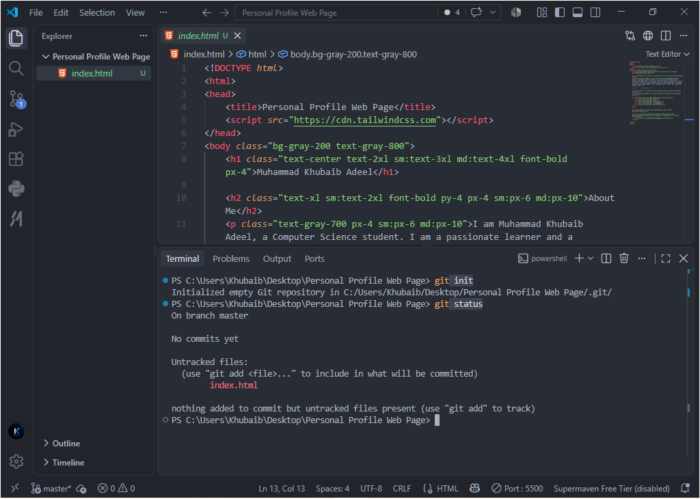
Part 2: Upload the Personal Profile Web Page on the Git repository. (Marks 3)
- Add your project files to Git using git add .
- Commit your project files using a meaningful commit message.
- Create/connect a remote repository such as GitHub.
- Push/upload your Personal Profile Web Page files to the remote repository.
- Attach a screenshot of the remote repository showing your uploaded files.
Screenshot showing Repository Push/Upload:
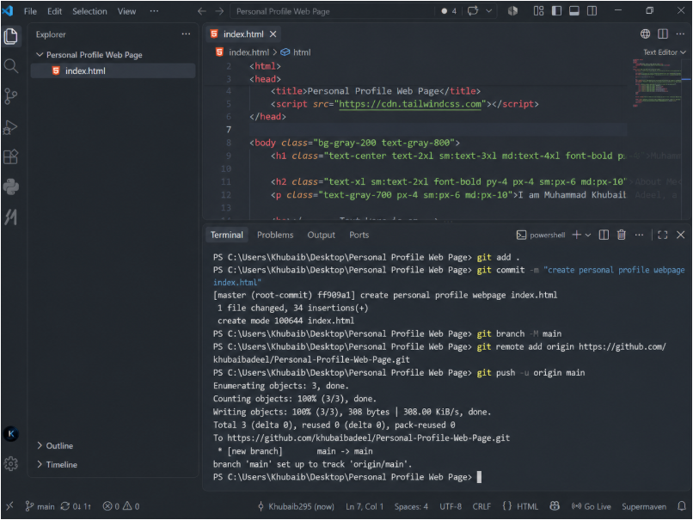
Screenshot showing GitHub Repository:
